Table of Contents

**Makar Sankranti: A Festival of Sun and Harvest** 2

Introduction: Welcoming the Light 2

Vedic Origins and Spiritual Significance 2

Mythological Stories Behind the Festival 3

A Festival of Harvest and Gratitude 3

Cultural Diversity and Common Spirit 3

Conclusion: A Timeless Celebration 4

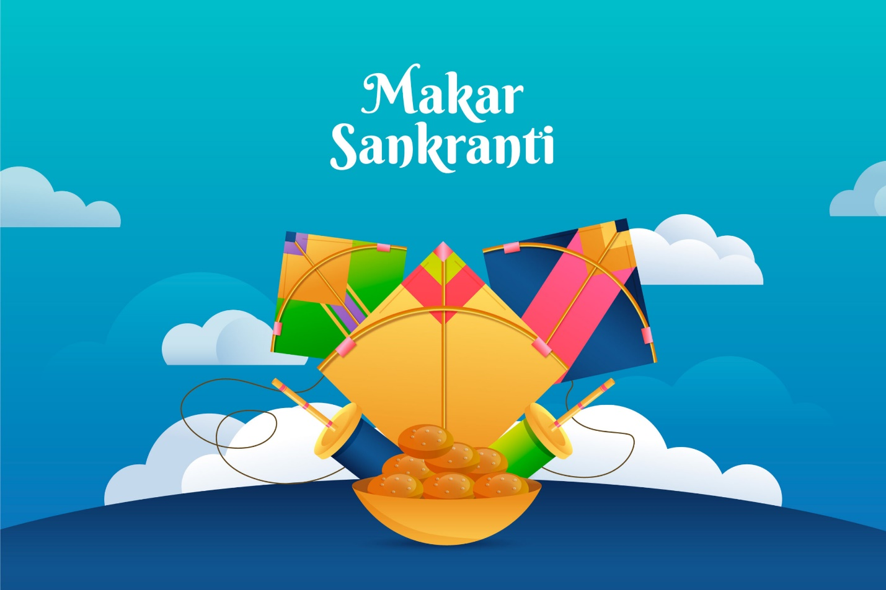

# **Makar Sankranti: A Festival of Sun and Harvest**

## Introduction: Welcoming the Light

Makar Sankranti is a major Hindu festival that celebrates the **Sun’s transition** into the zodiac sign of **Makara (Capricorn)**. It typically falls on **January 14th or 15th** every year and marks the beginning of **longer days and the end of winter**. This festival is celebrated across India with diverse cultural traditions, but the essence remains the same—**gratitude for the harvest, spiritual awakening, and the celebration of light over darkness**.

Vedic Origins and Spiritual Significance

The roots of Makar Sankranti lie in the **Vedic period**, where the **Sun God (Surya)** was worshipped as a source of wisdom, energy, and purity. The festival is named from two Sanskrit words:

* **Makar** – Capricorn
* **Sankranti** – transition or movement

This solar event, known as **Uttarayan**, is considered highly auspicious as it marks the beginning of a new cycle. Unlike lunar-based festivals, Makar Sankranti is based on the **solar calendar**, which is why it has a fixed date.

Mythological Stories Behind the Festival

Makar Sankranti is associated with several **Hindu legends**:

* **Surya and Shani**: According to mythology, Surya (the Sun) visits his son Shani (Saturn) on this day. Despite their past disagreements, this meeting is seen as a symbol of reconciliation and understanding.
* **Bhishma’s Departure**: In the epic *Mahabharata*, the great warrior **Bhishma Pitamah** chose to leave his mortal body on this day, believing it was the most auspicious time to attain **moksha (liberation)**.

These stories emphasize **divine harmony**, **spiritual strength**, and the **power of time**.

A Festival of Harvest and Gratitude

Makar Sankranti also signals the **end of the harvest season** in many parts of India. Farmers thank nature and the Sun God for a bountiful harvest. The festival is observed differently across the country:

* **Pongal** in Tamil Nadu
* **Uttarayan** in Gujarat
* **Lohri** in Punjab (celebrated on the eve)
* **Magh Bihu** in Assam
* **Khichdi Parv** in Uttar Pradesh and Bihar

People celebrate with **kite flying, bonfires, traditional foods** (like sesame and jaggery sweets), and **ritual river baths** believed to purify sins.

Cultural Diversity and Common Spirit

Despite regional differences, the core spirit of Makar Sankranti is universal:

* **Unity and family bonds**
* **Hope and positivity**
* **Connection to nature and cosmic rhythms**

The festival unites millions in a shared expression of **joy, renewal, and thankfulness**.

Conclusion: A Timeless Celebration

Makar Sankranti stands as a **timeless celebration of light, transition, and inner growth**. It reminds us that change is natural and beautiful, that light always returns after darkness, and that harmony—within ourselves, with others, and with nature—is the key to prosperity. Whether marked by soaring kites, sacred dips, or sweet delicacies, the festival continues to inspire **faith, warmth, and unity** across generations.